The settings for the interface are maintained in the menu On Line System > Administration > Packsize Interface Maintenance. The settings tab currently allows you to set the import/export paths, the label temp file, and the default bin.

The default bin is the bin that the part being issued will be issued from. If this is not set, the import will not run. If there is not enough quantity in this bin, the issue will fail. Failed issues can be viewed in Shop Floor Control > Transactions > WIP/Backflush Action Required

The import program that issues the material to the work order runs when online update processes. This will be issued to the material sequence on the work order with the part 9010999 . If there is no sequence on the work order with this part number, the material will not be issued.

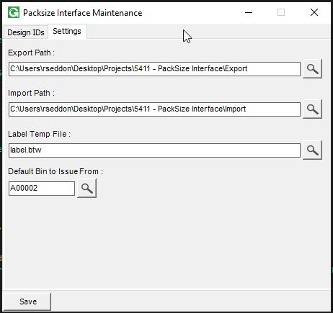

The Design IDs can be added / Maintained in the Design ID Tab. These will be available to select in the Inventory Part Packsize Data Maintenance screen.
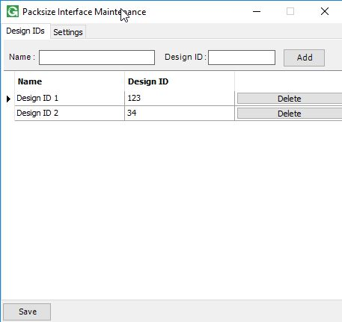

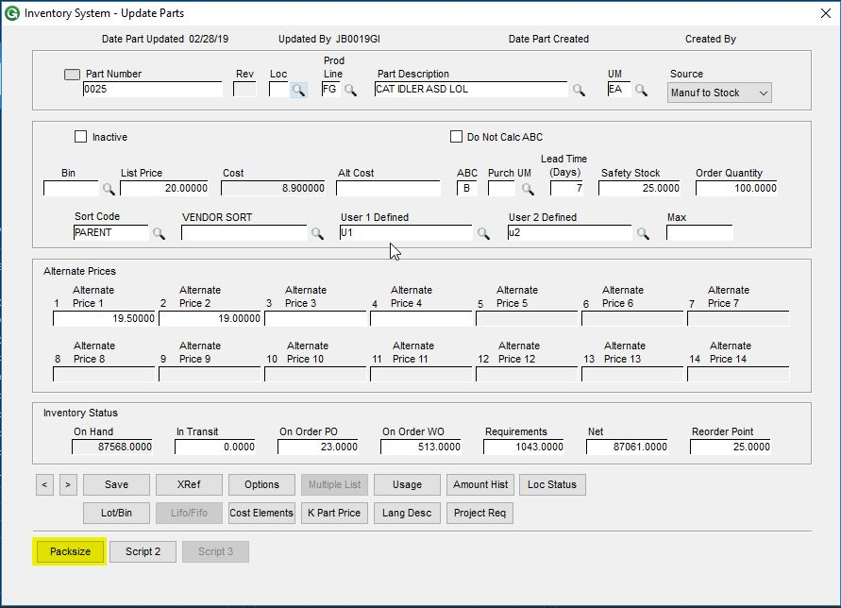
The Packsize data for each part is maintained in Inventory > File > Inventory Parts > Open, using the Script 1 button which has been renamed to Packsize.

In this menu you can set up the Packsize information for each part that will be sent to Packsize whenever a request is made.
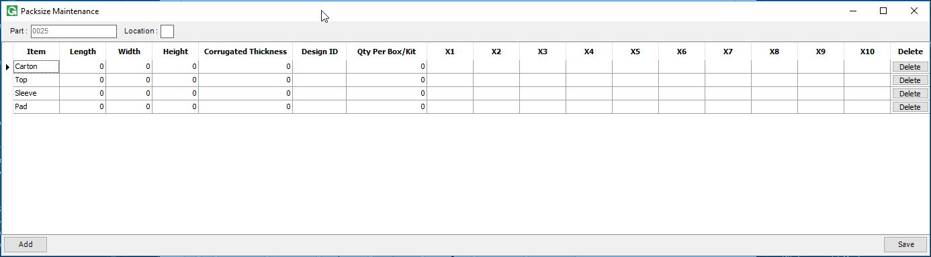

A Packsize request can now be made from the GUI Shop Floor Data Collection screen, using the Script 1 button which has been renamed to “Packsize”
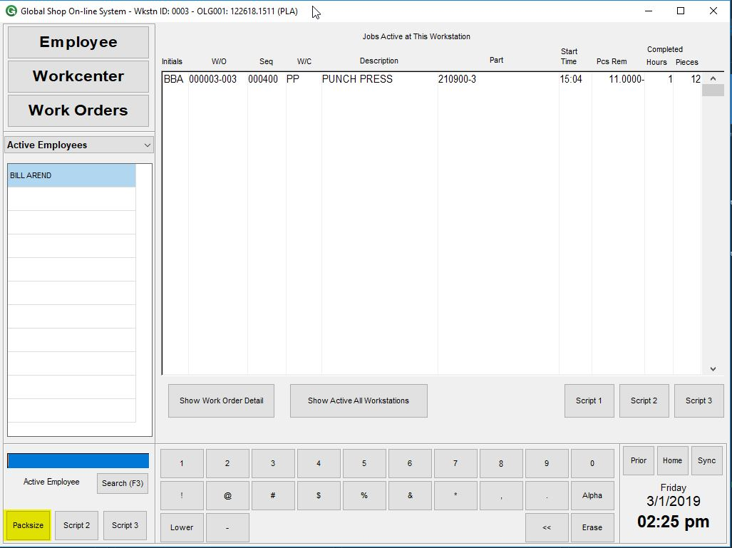

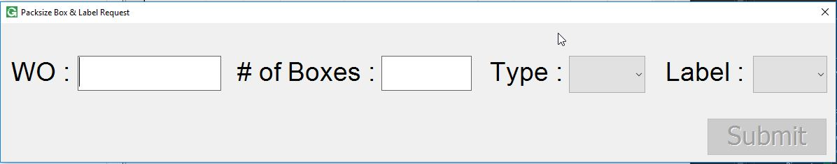
When clicked (with an Active Employee selected), the request screen will come up. Here the user needs to enter/scan in the Work Order Number (Work Order and Suffix, no divider), the number of boxes, the type, and the label. After that they can click submit and the request will be sent to Packsize. When Packsize sends a file back to Global Shop, the material used will be issued to the work order.

The work order and part number are checked against work orders and parts in Global Shop.

When the import runs, the file will be moved to a failed directory in the import directory if there are no usable records. If there are usable records, it will be moved to a processed folder in the import directory. The file being moved to the processed folder does not mean that the material was issued correctly, it only means that the work orders and quantities were valid and successfully passed to Global Shop to issue.

A log file of the import is created in Global\Custom\5411\5411_Log.txt

